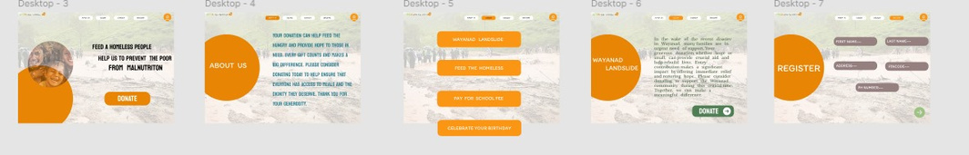

**donation app**

**Aim:**   
To develop a simple and user-friendly donation app that allows individuals to make donations to causes they care about with ease and security.

**Procedure:**

1. **Identify Key Features:**
   * **Browse Causes:** Users can browse various causes (e.g., charity organizations, disaster relief, environmental initiatives) and filter by category or location.
   * **One-Time and Recurring Donations:** Users can choose to make one-time donations or set up recurring donations for regular contributions.
   * **Payment Integration:** Integrate secure payment methods such as credit/debit cards, PayPal, or digital wallets (e.g., Apple Pay, Google Pay).
   * **Donation Tracking:** Allow users to track their donation history and receive receipts for tax purposes.
   * **Charity Profiles:** Each charity or cause should have a profile with details about their mission, impact, and current fundraising goals.
   * **Impact Visualization:** Provide information about how donations are being used (e.g., infographics, progress bars).
2. **Design UI/UX:**
   * **Clean Layout:** A straightforward, clean design focusing on simplicity. Clear categories for causes and easy navigation for donations.
   * **Personalized Experience:** After registration, show recommended causes based on the user's interests and past donations.
   * **Transparent Donation Process:** Clearly display the donation amounts, currency, and a breakdown of how the funds will be used. Make it easy to donate with minimal steps.
   * **Secure Checkout:** Use a seamless and secure payment process to make users feel confident about their donations.
   * **Thank You & Confirmation:** Display a thank-you message upon successful donation, and send confirmation emails or push notifications.
3. **Choose Development Tools:**
   * **For iOS:** Use Swift and integrate Stripe or Apple Pay for secure payments.
   * **For Android:** Use Kotlin with Google Pay or other payment gateway APIs.
   * **Backend:** Set up a backend (e.g., Firebase or AWS) to manage user accounts, donation tracking, and charity information.
4. **Develop the App:**
   * Build the front-end with smooth navigation for browsing causes, making donations, and viewing donation history.
   * Implement user accounts, allowing users to manage recurring donations, track progress, and view receipts.
   * Add payment gateway integration for various secure options like cards and PayPal.
5. **Testing:**
   * Test for bugs, especially in the donation process and payment gateway.
   * Ensure all payment methods are working securely and track donation history properly.
   * Verify that the app is responsive and easy to use on both iOS and Android.
6. **Launch:**
   * Launch the app after final testing and optimize the experience based on user feedback.

**Result:**   
A user-friendly donation app where users can browse and support causes they care about with a few simple steps. The app offers secure payment options, easy tracking of donations, and transparent details on how funds are used, encouraging users to make both one-time and recurring donations. The app provides a seamless, trustworthy experience for users to contribute to various causes.